Luke Ashton

Economics of Regulation

Term Paper

December 13th, 2021

Unemployment, Wages, and Regulatory Reform in British Columbia

***Introduction***

hfnknf

***Definitions***

It is important before any substantive analysis is written that there be an understanding of certain terms. “Regulation” is understood colloquially as a prohibition or requirement to do something, encapsulated by either a group of regulations that are administered by a non-legislative agency (think of the [Code of Federal Regulations](https://www.ecfr.gov/)) or by a set of statutes administered by a legislative body (the [United States Code](https://uscode.house.gov/)). However, regulation can also include suggestions where someone following it may do so willingly, and by not following will not suffer a penalty (such as regulatory guidelines). While this is still considered a regulation in a legal sense, for the purpose of this paper, regulation will be considered a requirement to do or a prohibition/restriction from doing a certain activity.

***Background***

***The (Micro) Economics of Regulation***

The knowledge that regulation has an economic impact is not a new one. George Stigler in his “Theory of Economic Regulation” (1971) notes that there is both a demand for regulation, and a supply of it predominately provided by state institutions.[1] The pure intent of regulation is to protect the public welfare from negative externalities or monopoly pricing associated with firm behavior. A classic example is the environment where a firm polluting the air is subject to public environmental regulation. In this case, it is much cheaper and easier for government regulators to regulate when the cost of negotiating away the externality becomes too great for private individuals impacted by the polluter. Examples like these serve as important reminders for when government intervention may be required, but the sinister side of regulation can generate their own negative externalities.

Stigler notes that protective regulation was used by railroad operators to hamstring the rise of intercity trucking to the point that states like Texas and Louisiana placed 7000-pound payload limits on trucks serving multiple railroad stations, and 14,000-pound limits on trucks serving one station. These state regulations specifically targeted trucking on behalf of railroad operators who they competed with in certain geographies and industries.[2] What Stigler encapsulates is ‘Regulatory Capture’, or the process of firms pressuring regulators to design regulations and laws in the firm’s favor. These instances of regulatory capture are most viscerally understood through pressure groups that represent a particular industry. Gary Becker (1983)[3] developed a theory of competition amongst pressure groups that used factors of pressure production efficiency, the number of people in groups, and the deadweight costs of taxes and subsidies that may incentive pressure or disincentivize it. The result of said pressure would usually mean taxes to punish a certain industry or subsidies to support one, but this can expand to other forms of regulation.

The earlier example from Stigler on trucking is one such regulation on entry while exits could also be controlled such as the ICC permitting or declining railroads to abandon certain freight and passenger services.[4] Banks also may be incentivized to capture regulators to take advantage of financial laws on the books or lobby for removal of certain regulations they find unsatisfactory.[5] These types of regulations focus on the regulated capturing the regulator, but rules put in by regulators without being captured can also have economic effects by unwittingly constraining industries even if the intention is to protect consumers.

Governments may regulate certain industries to prevent monopolies rising (anti-trust) or create regulated constraints on industries that naturally default to monopoly structure. In the latter case, American electric utilities are a well-known regulated monopoly administered by agencies such as the Federal Energy Regulatory Commission along with numerous state regulators with similar functions to the FERC. The clearest regulation is on rates, or the prices put on consumers for electricity. Stigler and Friedland (1962)[6] note that electric rates between regulated and unregulated states differ little and are statistically insignificant, bringing to question what costs regulation brings if outcomes between regulated and unregulated are minor. One such cost is through regulation on rate-of-return, or the percentage a regulated utility may take as income. Frank (2005)[7] notes that rate-of-return regulation has a negative impact on the rate of technical change (aka innovation) within electric companies in Texas, building upon previous articles by Nelson (1984) and Granderson (1999), the latter who found that regulated natural gas companies would invest more in innovation of noncapital goods over capital.

These articles highlight an important thread of thought within the microeconomics of regulation: regulation imposes costs on firms (or individuals) that alter their behavior, with some cases altering the behavior to suboptimal outcomes. Regulation is pervasive in almost every industry, and it falls onto both the regulators and regulated to understand what impacts regulation has on society. It becomes an issue when this is not done, and old regulation is left alone without substantive review and is allowed to be compounded upon with new regulations. Multiply this across industries and it quickly becomes clear that regulation left untouched can have profound effects on the economy as a whole.

***Regulatory Accumulation and its Macroeconomic Impact***

Regulation and its economic impact have traditionally been understood as microeconomic problems i.e., a firm engages in regulatory capture or the state seeks to limit monopolistic tendencies. However, quantifying the amount of regulation can take a microeconomic problem and bring it into the macroeconomic realm to the point where indicators like Total Factor Productivity (TFP), GDP, unemployment, and income inequality can be better understood. Attempts to bring regulation into the macroeconomic realm have led to two major methods of understanding; firstly, through surveys or expert feedback on regulatory environments that create indices, while the second method measures regulatory documents directly by developing metrics that quantify regulation. In both methods there is an understanding of “regulatory accumulation” within nations, or the buildup of laws and regulation overtime without reform or removal. However, the former method implicitly ties accumulation to economic outcomes while the latter method takes a more direct approach at quantifying regulation and how certain quantities can impact economies.

These two approaches highlight an important distinction: it is very difficult to develop a common understanding of what regulation is. Dawson and Seater (2013) succinctly encapsulate this issue: “How should one measure the amount of regulation contained in the prohibition ‘Thou shalt not pollute,’ and how should it enter a macroeconomic model? Modern growth theory actually does give us some guide to how to address the latter modeling issue, but it does not tell us exactly what to measure.” This paper seeks to add to this last conundrum of what exactly to measure by expanding what previous authors have done and connecting the ideas between the implicit and explicit threads of thought.

***Implicit Regulatory Accumulation***

Some of the earliest studies come from the vein of implicit regulatory accumulation. Djankov, McLiesh, and Ramalho (2005) study regulation based on the World Bank’s Doing Business Database and its impact on GDP growth.[8] They find that regulation has a significant effect on GDP growth between countries, with countries that move from the worst quartile to the best see a 2.3 percentage point increase in average annual growth. Djankov, Georgieva, and Ramalho (2019) later add to the study by looking at business regulation and poverty between countries, noting that countries with less or business-friendly regulation had lower rates of poverty than countries with more intrusive regulatory environments. Other studies have taken an identical approach when looking at factors like income inequality. Ashby and Sobel (2008) take panel data for US states and compare an economic freedom index with income inequality, noting that states with higher levels of economic freedom have higher income and higher rates of income growth.

***Explicit Regulatory Accumulation***

Advancements in computing technology allows for more options to study regulation to the point where it is much easier to quantify regulation on specific industries or occupations. The first attempts in this method have been simple: count the number of pages of regulation. Dawson and Seater (2013)[9] measure regulatory accumulation by counting the number of pages within the CFR and analyzing how increases in page counts of regulation impact macroeconomic indicators. They find that regulation have negative impacts on real output growth by 2% between 1949 and 2005, estimating that if regulation had stayed at 1949 levels it would mean a 2011 GDP of $53.9 trillion instead of $15.1 trillion. They also find that regulation affects trends of TFP, labor, and physical capital, though they note that they were unable to attribute to specific industries tied to CFR titles due to too few degrees of freedom.

Coffey, McLaughlin, and Peretto (2020)[10] add to Dawson and Seater’s work by moving away from page counts and attributing restrictions to particular industries through a Natural Language Process and Machine Learning system called RegHub. RegHub takes words or phrase like “must” or “shall not” and quantifies them based on identifiable industry traits within the CFR (such as key words and phrases related to an industry, or the titles of subheadings in the CFR). They take a counterfactual approach by freezing regulation in 1980 to understand how outcomes like GDP and output are changed. They find that there is a 0.8% loss in real growth rates since 1981 with a similar loss in GDP compared to the counterfactual, culminating in a difference of $4 trillion in 2012.

***A Snapshot of Regulatory Accumulation***

Regulatory accumulation is a phenomenon seen in multiple countries around the world. There have been large increases in the number of restrictions just since 2000, with Canada, Australia, and the United States experiencing increasing levels on a real and per capita basis. Figure 1 shows restrictions per 1000 people in the aforementioned states, with Australia in particular seeing large increases since RegHub started measuring Australia’s code. Canada and the United States have also seen increases albeit at a lower rate.

The United States saw an increase in the number of restrictions[11] with the Code of Federal Regulations jumping from 405,000 in 1970 to almost 1.1 million in 2019.

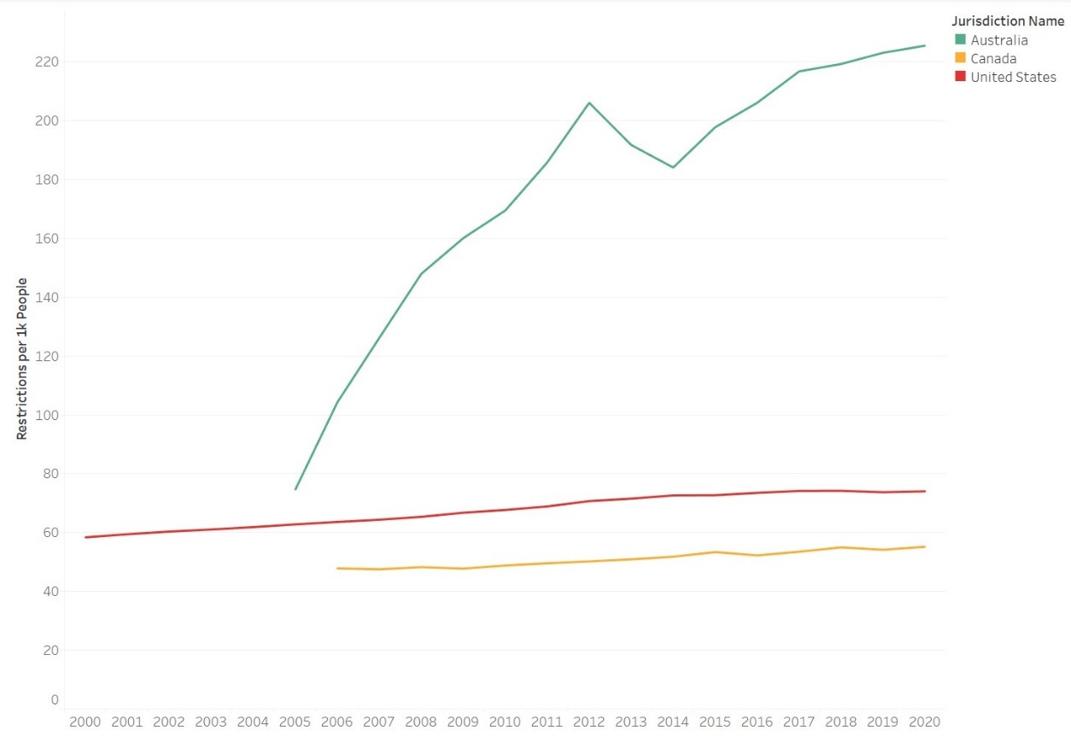

Figure – Restrictions per 1000 People in the US, Canada, and Australia, data: RegData 4.0 and World Bank

***The Example of British Columbia***

British Columbia’s 2001 election was a landslide victory for the center-right BC Liberal Party[12] against the left-wing New Democratic Party. Out of a total of 79 seats, the Liberals won 77, generating the largest majority ever in the provincial parliament for the party to implement its policy objectives. Amidst a large package of reforms and tax cuts, a regulatory budget, entitled the *Red Tape Reduction Programme*, became one of the defining legacies of the era to the point that several other provincial governments and the federal government of Canada replicated its success.[13] It was a simple concept: for each new regulation on the books, at least two must be removed.[14] The government set a goal of a 40% regulatory reduction by 2004 with a subsequent cap on regulation based on a 2004 baseline to be in place until 2022.[15] The first problem they faced was how to define regulation, and then quantify it.

The definition they decided on is as follows: “A regulatory requirement is any action or step that must be taken to access services, carry out business, or meet legal responsibilities under provincial legislation, regulation, policy, or forms.”[16] An initial count of 330,812 was determined under this definition. This was reduced to 197,242 by 2004 as the program took effect, a 40.3% reduction with subsequent years continuing the trend. The count currently stands at 168,475 requirements as of 2021.[17] A few studies have tried to understand the impact the regulatory budget had on British Columbia’s economy. Jones (2015) through a summary analysis and industry feedback makes a case for better economic growth, noting that mining in particular was stagnate in the 1990’s but rebounded in the early 2000’s because the province had “taken many important steps—improving its tax competitiveness, streamlining regulatory requirements and investing in the province’s geosciences mineral data collection and analysis…”.[18] More recently, Coffey and McLaughlin (2021)[19] look at the impact the program had on GDP growth, finding that the regulatory budget contributed to a 1% increase in year-to-year GDP growth for the province.[20]

***Research Design***

The study by Coffey and McLaughlin (2021) is particularly interesting for this paper in that the authors find a clear association between removing regulation and GDP growth at the aggregate. This is the only substantive empirical analysis done on the policy by British Columbia, leaving room for additional research on factors outside GDP. This paper adds to the literature on British Columbia by replicating the model Coffey and McLaughlin created and changing the dependent variables to unemployment and average wages, taking what has been researched in other jurisdictions and applying it to British Columbia based on a model designed for British Columbia.

***Analytical Approach***

This analysis focuses on two hypotheses: 1) The Red Tape Program had a significant negative effect on unemployment, and 2) The Red Tape Program had a significant positive effect on average wages. A simple series of Diff-in-Diff regressions are used to compare when British Columbia implemented its Red Tape program in 2001, and the post-2001 effect of the treatment until 2008 to discard any potential fluctuations due to the Great Recession.

: Unemployment and Wages are the two dependent variables for this analysis with the same model being applied separately

: Several fixed effects are included to control for province, year, and industry

: the difference of unemployment between British Columbia and other provinces

: the difference in unemployment between the years 2001 and 2008

: interaction variable of the difference in unemployment on the treatment province and years

***Data***

Following the precedence from the Coffey and McLaughlin (2021) paper on British Columbia on the independent variables, the unique data for the dependent variables on wage and unemployment data come from Statistics Canada between the years 1997 and 2015. Both unemployment and wage data are divided between industries at the NAICS 2-digit level which is organized as follows:



Figure – Summary Statistics on Unemployment



Figure – Summary Statistics on Average Hourly Wages in Canadian Dollars

Industries follow the 2-digit level because of a lack of data in the 3- or 4-digit range for wages and unreliable data for unemployment within certain industries at the 3-digit level either due to no notable industry existing or data privacy laws that Statistics Canada follows. The study excludes certain data on both a geographic and industry basis. The three territories of Canada are not included due to their small populations and lack of industry-specific data provided by Statistics Canada, and the Maritime provinces (Newfoundland and Labrador, Nova Scotia, New Brunswick, and Prince Edward Island) are excluded from certain analyses to account for missing data and lack of data variation. Two notable industries at the NAICS 2-digital level are excluded for two reasons. Utilities are excluded due to a lack of data from Statistics Canada on the ground of data privacy, and Public Administration is excluded due to its nature of being a government-dominated industry (this is likely why utilities have a lack of data).

There are a few issue areas with the data to be cognizant of in the context of the analysis. Firstly, only NAICS 2-digit level data is available for unemployment and wages where the original analysis by Coffey and McLaughlin includes data at the 3-digit level, providing a larger number of observations than this analysis.

**Table 1 – Diff-in-Diff Regressions on Unemployment**



**Table 2 – Diff-in-Diff Regressions on Average Hourly Wages**



1. Stigler, George J. “The Theory of Economic Regulation.” *The Bell Journal of Economics and Management Science*, vol. 2, no. 1, 1971, pp. 3–21., https://doi.org/10.2307/3003160.
2. Stigler
3. Becker, Gary S. “A Theory of Competition among Pressure Groups for Political Influence.” *The Quarterly Journal of Economics*, vol. 98, no. 3, 1983, p. 371., https://doi.org/10.2307/1886017.
4. Peltzman, Sam, et al. “The Economic Theory of Regulation after a Decade of Deregulation.” *Brookings Papers on Economic Activity. Microeconomics*, vol. 1989, https://doi.org/10.2307/2534719.
5. Hardy, Daniel. “Regulatory Capture in Banking.” *International Monetary Fund Working Papers*, vol. 06, no. 34, Jan. 2006, https://doi.org/10.5089/9781451862942.001.
6. Stigler, George J., and Claire Friedland. “What Can Regulators Regulate? the Case of Electricity.” *The Journal of Law and Economics*, vol. 5, 1962, pp. 1–16., https://doi.org/10.1086/466579.
7. Frank, Mark W. “An Empirical Analysis of Electricity Regulation on Technical Change in Texas.” *Review of Industrial Organization*, vol. 22, no. 4, 2003, pp. 313–331., https://doi.org/10.1023/a:1025591800401.
8. The Doing Business Database primarily relies on survey data from legal experts from various countries and regions which is then indexed into the database.
9. Dawson, John W., and John J. Seater. “Federal Regulation and Aggregate Economic Growth.” *Journal of Economic Growth*, vol. 18, no. 2, 2013, pp. 137–177., https://doi.org/10.1007/s10887-013-9088-y.
10. Coffey, Bentley, et al. “The Cumulative Cost of Regulations.” *Review of Economic Dynamics*, vol. 38, 2020, pp. 1–21., https://doi.org/10.1016/j.red.2020.03.004.
11. Restrictions are defined as a requirement to do or not do a particular activity. This is quantified through counting the number of times a phrase like “shall”, “shall not”, “must”, etc appear in the CFR.
12. Unaffiliated with the federal center-left Liberal Party in Canada
13.
14. This was eventually changed to a “one-in-one-out” policy
15. This is after several extensions in 2015 and
16. https://www2.gov.bc.ca/gov/content/governments/about-the-bc-government/regulatory-reform/resources
17. Annual report 2020-2021
18. Jones, Laura. “Cutting Red Tape in Canada: A Regulatory Reform Model for the United States?” *Mercatus Center at George Mason University*, Nov. 2015, https://doi.org/10.2139/ssrn.3191396.
19. Coffey, Bentley, and Patrick A. McLaughlin. “Regulation and Economic Growth: Evidence from British Columbia’s Experiment in Regulatory Budgeting.” *Mercatus Center at George Mason University*, May 2021, https://doi.org/10.2139/ssrn.3868527.
20. The authors noted that for a 1% increase in regulation, it is associated with a 0.028% decrease in year-to-year economic growth.